Each degree at Vaasa University of Applied Sciences includes general competence related learning outcomes that graduating students should possess upon completion of their studies. These competences are often referred to as generic skills, transferable skills, or worklife skills. Some of these competences are developed through separate study modules, some are integrated into individual study units, and some are developed as themes throughout the degree program.
This is a self-assessment form that guides you in reflecting on your own competences and their development. Your responses will be reviewed during annual development discussions with your group counsellor.

General workplace competences at VAMK are based on the following recommendations:
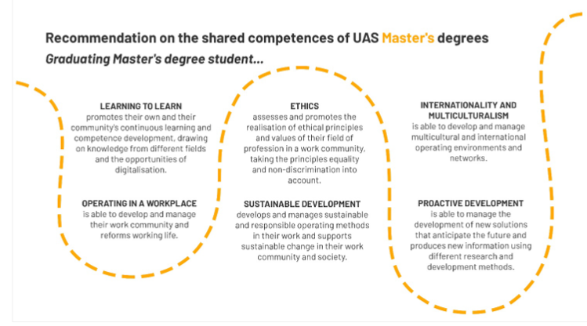
Source

Instructions for self-assessment:

- Reflect on how your competences have developed during your studies according to the statements below. Choose Yes / Somewhat / Not yet. If only one part of the statement applies, choose the answer option: somewhat.

- In the Additional Information section, you can specify your response: In which areas have you improved? What methods do you recognize for development? Is there anything else you would like to add?

Competence Goal / Self-Assessment Statement | Yes | Some what | Not yet | Additional Information
Development of Competence and Critical Thinking
I am able to learn new things, and assess my learning and development (e.g., reflection skills, self-assessment). | ☐ | ☐ | ☐
I can create new knowledge based on the information I have gathered, as well as critically evaluate information and consider various perspectives. | ☐ | ☐ | ☐
Working in the Workplace and Workplace Skills
I recognize the impact of my own example and actions in the work community. | ☐ | ☐ | ☐
I am able to develop the communication and interaction culture within work communities. | ☐ | ☐ | ☐
I am able to develop and lead the overall well-being of work communities. | ☐ | ☐ | ☐
I am able to promote the adaptability and resilience of work communities (flexibility, psychological recovery capacity, reorientation). | ☐ | ☐ | ☐
I am able to develop and lead multidisciplinary teams and work communities. | ☐ | ☐ | ☐
I am able to balance my work and other aspects of my personal life (e.g., work, family, friendships, hobbies). | ☐ | ☐ | ☐
Responsibility and Ethical Conduct
I am able to promote responsible and ethically sustainable practices. | ☐ | ☐ | ☐
I understand and reflect on the implementation of responsibility and ethics in various contexts. | ☐ | ☐ | ☐
I can promote the realization of professional ethical principles and values (e.g., ethical and customer-oriented practices specific to the field: safety, confidentiality, privacy protection). | ☐ | ☐ | ☐
I consider individual, communal, and societal perspectives in the decisions I make. | ☐ | ☐ | ☐
I promote the realization of diversity and accessibility. | ☐ | ☐ | ☐
I implement the principles of good scientific practice and promote their application in my work community. | ☐ | ☐ | ☐
I can ethically lead socially impactful actions. | ☐ | ☐ | ☐
I can evaluate the dependencies of various problems and challenges and the effects of solutions derived from them within the work community. | ☐ | ☐ | ☐
I can lead the exploration and implementation of more responsible models and alternatives within the work community. | ☐ | ☐ | ☐
I can lead the establishment of more responsible models into practice. | ☐ | ☐ | ☐
Internationality and Multiculturalism
I consider multiculturalism in my actions. | ☐ | ☐ | ☐
I can develop practices that take multiculturalism into account within my work community. | ☐ | ☐ | ☐
I can anticipate global developments and the impacts of phenomena in my own work. | ☐ | ☐ | ☐
I can consider the opportunities presented by global developments and phenomena in my own work. | ☐ | ☐ | ☐
I can interact and develop in my field internationally. | ☐ | ☐ | ☐
Innovation and Proactive Development, Proactive Development
I systematically generate new knowledge and innovate practices by combining expertise from various fields. | ☐ | ☐ | ☐
I can implement RDI (Research, Development, and Innovation) projects and apply various research and development methods. | ☐ | ☐ | ☐
I develop operations with a future-oriented approach. | ☐ | ☐ | ☐
I can develop operations in a customer-oriented, economically profitable, and sustainable manner. | ☐ | ☐ | ☐
I can lead and develop continuous learning within the work community with clear objectives. | ☐ | ☐ | ☐
I can analyze the current situation and anticipate the future of my field as well as potential changes in the operating environment. | ☐ | ☐ | ☐
I can leverage the opportunities of technology and digitalization in development and leadership. | ☐ | ☐ | ☐
I recognize the opportunities offered by artificial intelligence in my field and can utilize them in my work responsibly and ethically. | ☐ | ☐ | ☐

